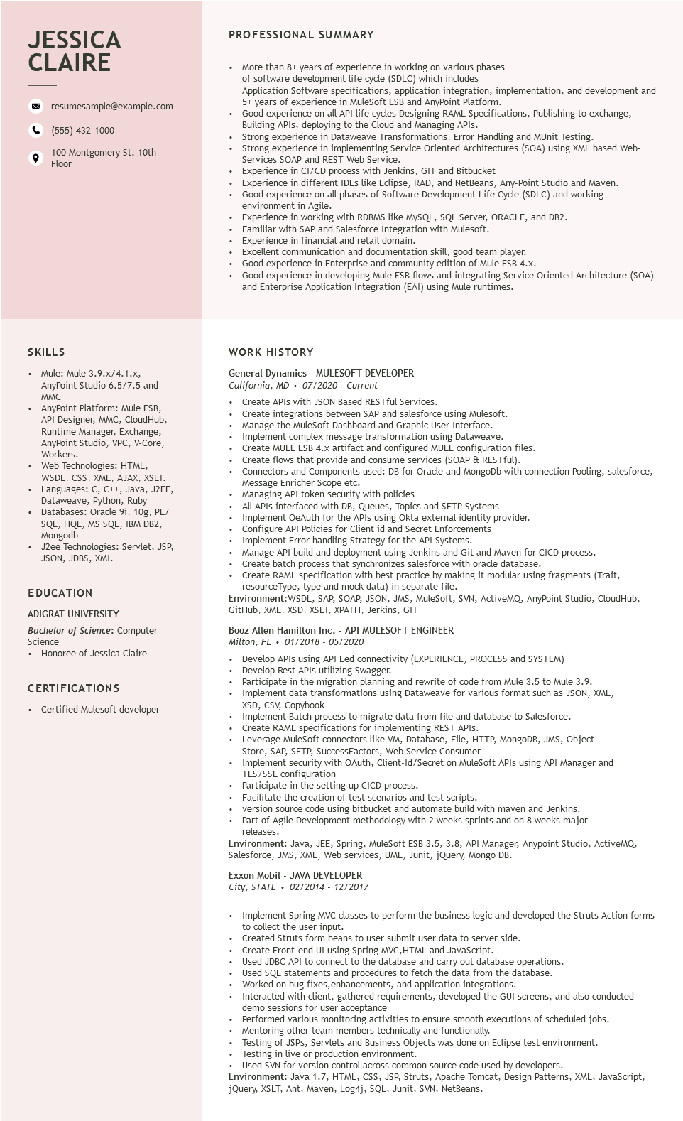
JESSICA CLAIRE
resumesample@example.com
(555) 432-1000
100 Montgomery St. 10th Floor
PROFESSIONAL SUMMARY
More than 8+ years of experience in working on various phases
of software development life cycle (SDLC) which includes
Application Software specifications, application integration, implementation, and development and 5+ years of experience in MuleSoft ESB and AnyPoint Platform.
Good experience on all API life cycles Designing RAML Specifications, Publishing to exchange, Building APIs, deploying to the to the Cloud and Managing APIs.
Strong experience in Dataweave Transformations, Error Handling and MUnit Testing.
Strong experience in implementing Service Oriented Architectures (SOA) using XML based Web- Services SOAP and REST Web Service.
Experience in CI/CD process with Jenkins, GIT and Bitbucket
Experience in different IDEs like Eclipse, RAD, and NetBeans, Any-Point Studio and Maven. Good experience on all phases of Software Development Life Cycle (SDLC) and working
environment in Agile
Experience in working with RDBMS like MySQL, SQL Server, ORACLE, and DB2.
Familiar with SAP and Salesforce Integration with Mulesoft.
Experience in in financial and retail domain.
Excellent communication and documentation skill, good team player.
Good experience in Enterprise and community edition of Mule ESB 4.x.
Good experience in developing Mule ESB flows and integrating Service Oriented Architecture (SOA)
and Enterprise Application Integration (EAI) using Mule runtimes.
SKILLS
• Mule: Mule 3.9.x/4.1.x, AnyPoint Studio 6.5/7.5 and MMC
• AnyPoint Platform: Mule ESB, API Designer, MMC, CloudHub, Runtime Manager, Exchange, AnyPoint Studio, VPC, V-Core, Workers.
Web Technologies: HTML, WSDL,
CSS, XML, AJAX, XSLT. Languages: C, C++, Java, J2EE, Dataweave, Python, Ruby Databases: Oracle 9i, 10g, PL/ SQL, HQL, MS SQL, IBM DB2, Mongodb
⚫ J2ee Technologies: Servlet, JSP, JSON, JDBS, XMI.
EDUCATION
ADIGRAT UNIVERSITY
Bachelor of Science: Computer Science
⚫ Honoree of Jessica Claire
CERTIFICATIONS
• Certified Mulesoft developer
WORK HISTORY
General Dynamics - MULESOFT DEVELOPER California, MD 07/2020 - Current
Create APIs with JSON Based RESTful Services.
Create integrations between SAP and salesforce using Mulesoft. Manage the MuleSoft Dashboard and Graphic User Interface. Implement complex message transformation using Dataweave.
Create MULE ESB 4.x artifact and configured MULE configuration files.
Create flows that provide and consume services (SOAP & RESTful).
Connectors and Components used: DB for Oracle and MongoDb with connection Pooling, salesforce, Message Enricher Scope etc.
Managing API token security with policies
All APIs interfaced with DB, Queues, Topics and SFTP Systems
Implement OeAuth for the APIs using Okta external identity provider.
Configure API Policies for Client id and Secret Enforcements
Implement Error handling Strategy for the API Systems.
Manage API build and deployment using Jenkins and Git and Maven for CICD process.
Create batch process that synchronizes salesforce with oracle database.
Create RAML specification with best practice by making it modular using fragments (Trait,
resourceType, type and mock data) in separate file.
Environment:WSDL, SAP, SOAP, JSON, JMS, MuleSoft, SVN, ActiveMQ, AnyPoint Studio, CloudHub, GitHub, XML, XSD, XSLT, XPATH, Jerkins, GIT
Booz Allen Hamilton Inc. - API MULESOFT ENGINEER
Milton, FL
01/2018 - 05/2020
Develop APIs using API Led connectivity (EXPERIENCE, PROCESS and SYSTEM) Develop Rest APIs utilizing Swagger.
Participate in the migration planning and rewrite of code from Mule 3.5 to Mule 3.9. Implement data transformations using Dataweave for various format such as JSON, XML, XSD, CSV, Copybook
Implement Batch process to migrate data from file and database to Salesforce.
Create RAML specifications for implementing REST APIs.
Leverage MuleSoft connectors like VM, Database, File, HTTP, MongoDB, JMS, Object
Store, SAP, SFTP, SuccessFactors, Web Service Consumer
Implement security with OAuth, Client-Id/Secret on MuleSoft APIs using API Manager and TLS/SSL configuration
Participate in the setting up CICD process.
Facili
Facilitate the creation of test scenarios and test scripts.
version source code using bitbucket and automate build with maven and Jenkins.
Part of Agile Development methodology with 2 weeks sprints and on 8 weeks major releases.
Environment: Java, JEE, Spring, MuleSoft ESB 3.5, 3.8, API Manager, Anypoint Studio, ActiveMQ, Salesforce, JMS, XML, Web services, UML, Junit, jQuery, Mongo DB.
Exxon Mobil - JAVA DEVELOPER
City, STATE 02/2014 - 12/2017
Implement Spring MVC classes to perform the business logic and developed the Struts Action forms to collect the user input.
Created Struts form beans to user submit user data to server side.
Create Front-end UI using Spring MVC,HTML and JavaScript.
Used JDBC API to connect to the database and carry out database operations.
Used SQL statements and procedures to fetch the data from the database.
Worked on bug fixes, enhancements, and application integrations.
Interacted with client, gathered requirements, developed the GUI screens, and also conducted demo sessions for user acceptance
Performed various monitoring activities to ensure smooth executions of scheduled jobs.
Mentoring other team members technically and functionally.
• Testing of JSPs, Servlets and Business Objects was done on Eclipse test environment.
• Testing in live or production environment.
• Used SVN for version control across common source code used by developers.
Environment: Java 1.7, HTML, CSS, JSP, Struts, Apache Tomcat, Design Patterns, XML, JavaScript, jQuery, XSLT, Ant, Maven, Log4j, SQL, Junit, SVN, NetBeans.

